Requirement Analysis Phase
Phase 2: Create new Custom table
The Requirement Analysis Phase identifies the functional and technical requirements needed to import employee data from an external spreadsheet into the ServiceNow platform using Import Sets and Transform Maps.

1. Functional Requirements
- The system should accept employee data provided in an Excel spreadsheet.
- The spreadsheet should contain structured employee information such as:
  - Employee ID
  - Employee Name
  - Email
  - Department
  - Job Title
  - Location
- The system should allow the spreadsheet data to be loaded into a ServiceNow Import Set Table.
- A Transform Map should be created to connect source fields with the corresponding fields in the target table.
- The system should transform and transfer the imported data into the appropriate target table.
- The system should identify and handle invalid or incomplete records where applicable.
- The imported records should be verified after the transformation process.
- The system should maintain data accuracy and consistency during the import process.

2. Technical Requirements
- A ServiceNow instance with appropriate administrator access.
- An Excel spreadsheet containing employee data.
- An Import Set Table to temporarily store the source data.
- A Transform Map for mapping source fields to target fields.
- Appropriate target-table fields for storing employee information.
- Access to System Import Sets and related ServiceNow modules.

3. Data Requirements
Source Field | Target Field | Description
Employee ID | Employee ID | Unique employee identifier
Employee Name | Name | Employee's full name
Email | Email | Employee email address
Department | Department | Employee's department
Job Title | Job Title | Employee's designation
Location | Location | Employee's work location

4. Validation Requirements
After the transformation, the project should verify that:
- Employee records are successfully created in the target table.
- Source fields are correctly mapped to target fields.
- Required fields contain valid data.
- Duplicate or invalid records are identified appropriately.
- The number of successfully imported records matches the expected result.
- The imported employee information is displayed correctly in ServiceNow.
Create new Custom table
Navigation:
- Tables > Create New
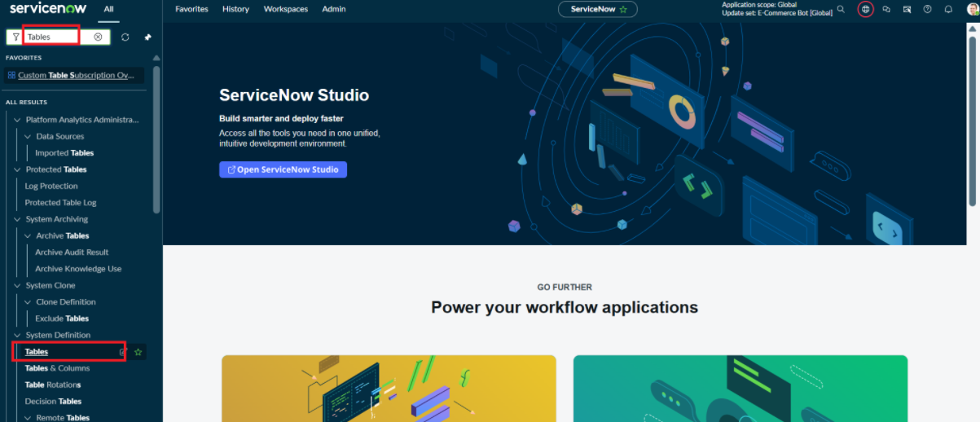
- Label: Employee Test
- Name: u_employee_test
- After creating and saving the Employee Test table, scroll down to the bottom of the table form.
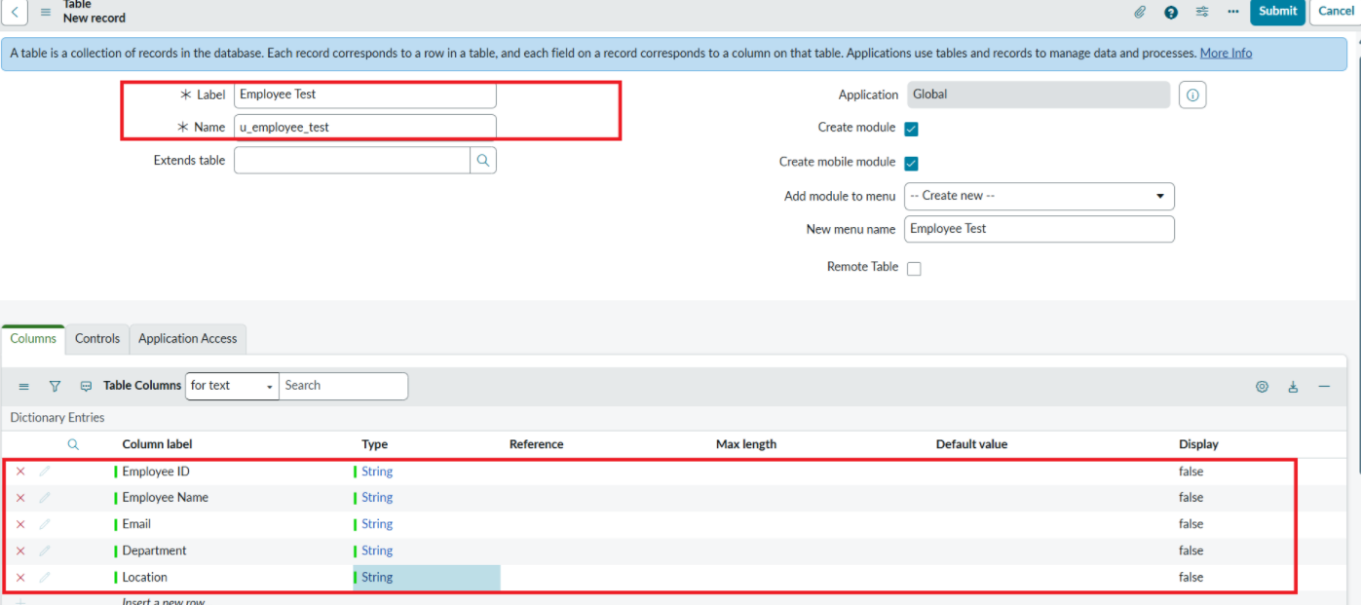
- Click Show Form to open the table form.
- On the form, locate the Form Context Menu / Additional Actions option on the left side of the form header.
- Click the Form Context Menu / Additional Actions icon.
- Click configure , select Form Layout.
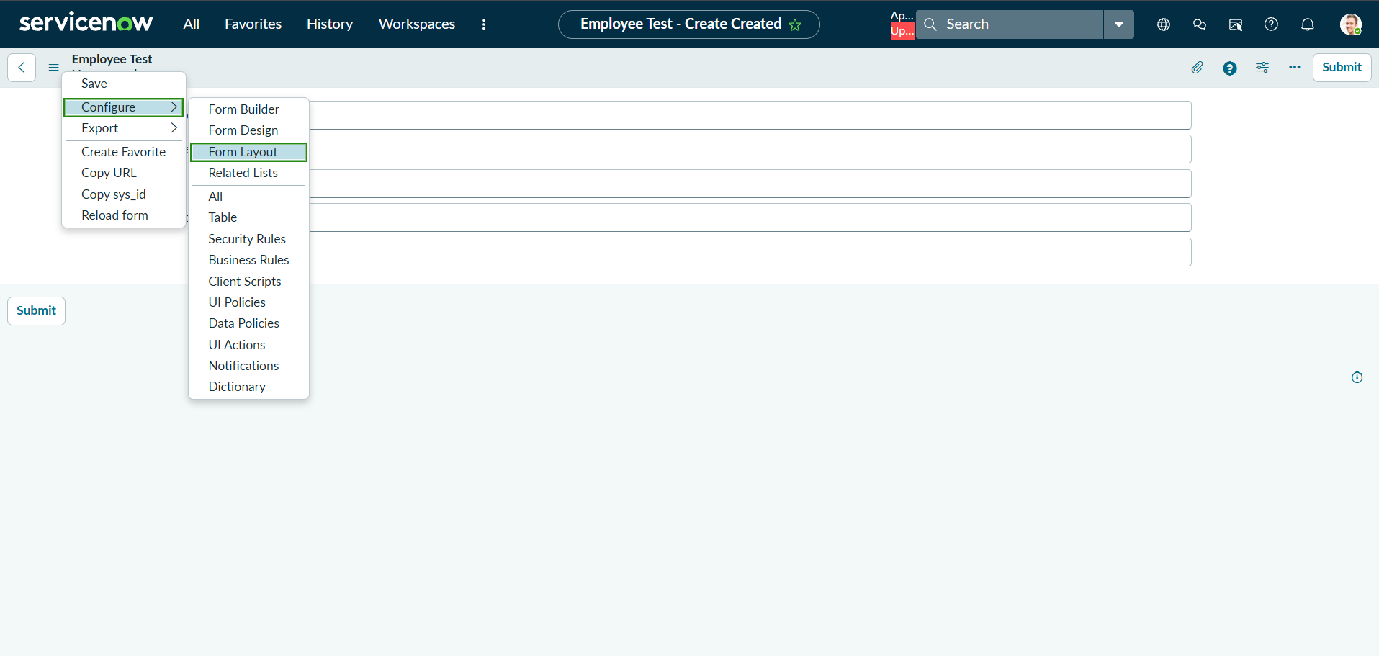
- The Form Layout page will open, where you can configure the fields displayed on the form
- After opening Form Layout, click New to create a new field.
- Enter the field details:
- Column Label: Employee ID
- Type: String
- Click Add to create the field.

- Repeat the same steps to create the following fields:
  - Employee Name – Type: String
  - Email – Type: String
  - Department – Type: String
  - Location – Type: String
- After creating all the required fields, click Save.
- Verify that the newly created fields are displayed on the Employee Test form.
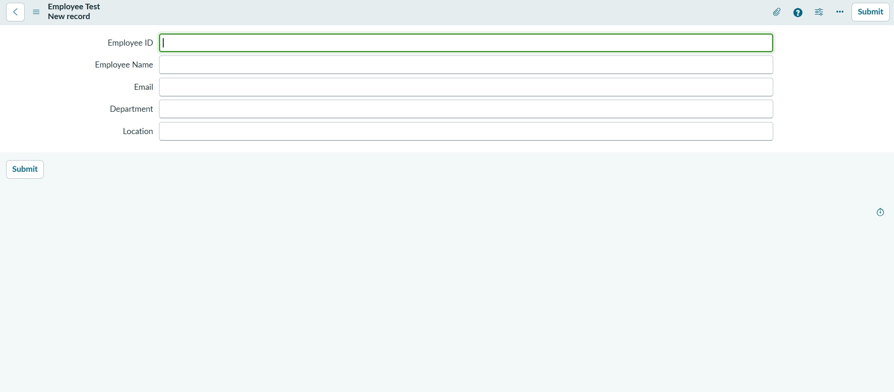
Click on Submit or Save.

